

Admission Policy 2026/2027
for Stanhope Primary and Nursery School

Reviewed and approved by Governing Body 11.12.2024

Admission arrangements for children starting school 2026-2027

Admissions for children about to start school are decided by the governors of the school, but the process is coordinated by Nottinghamshire County Council’s Admissions Office - www.nottinghamshire.gov.uk/admissions
email: admissions.ed@nottscc.gov.uk

Parents/carers are required to apply on a common application form through the child’s home local authority. The closing date for applications is 15th January 2026. Outcomes for on-time applications will be communicated to parents on National Offer Day 16th April 2026 or the next working day as per 2.12c of the Code.

The published admission number per year group is 60.

Late applications for school places
Any late applications will be processed in line with the coordinated scheme.

Admission oversubscription criteria
In the event of over subscription, the following criteria will be applied, in priority order, to determine which applications will be granted once places have first been allocated to pupils who have an Education, Health and Care Plan which names the school:

- Looked after children and previously looked after children, including those children who appear (to the admission authority) to have been in state care outside of England and ceased to be in state care as a result of being adopted.
- Children who live in the catchment area at the closing date for applications and who, at the time of admission, will have a brother or sister attending the school.
- Other children who live in the catchment area at the closing date for applications.
- Children who live outside the catchment area who, at the time of admission, will have a brother or sister attending the school.
- Children who live outside the catchment area.

Catchment area map:

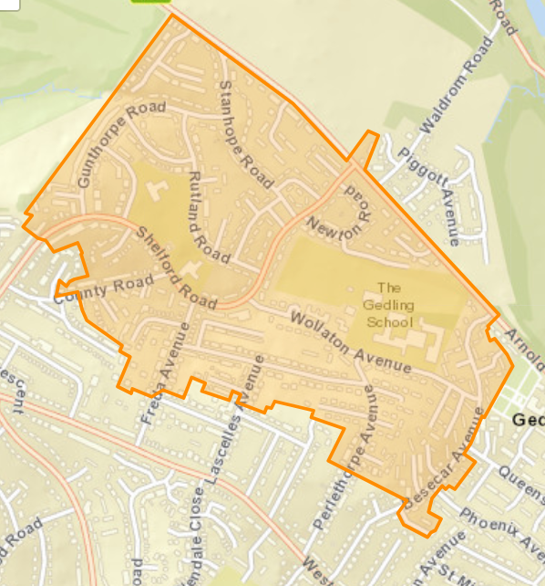

Distance measurement
In the event of over subscription within each of the criteria, priority will be given to children who live nearest the school as the crow flies (by straight line). Distances are measured from the main administrative point at the school campus to an address point (using eastings and northings as defined by Ordnance Survey) to the child’s home using the local authority’s computerised distance measuring software.

In the event of two distances being equal, random allocation will be used as tie-break. This process will be independently verified by someone outside of the school.

Where one child of a multiple birth can be admitted, the other child/children will also be admitted.

Waiting lists are held for the reception intake year and will be held until the end of the Summer Term.
Children offered a place in our school who were born between 1 September and 31 August of the appropriate admission year, have the option to start full-time school from the beginning of the autumn term. Parents may choose to defer their child’s admission to the following term or until the beginning of the term following their child’s fifth birthday, provided that the child’s admission takes place within the current school year and subject to discussion with the Head of School.

Should parents of summer born children choose to defer their child’s admission until the September after their fifth birthday and request their child enter the reception class the admission authority will make a decision on the basis of the circumstances of each individual case. Where this is agreed the parent must re-apply for a school place.

Special Circumstances
The following groups of children will be given special consideration in their application for a particular school: children whose particular medical needs, mobility support needs, special educational needs or social circumstances are supported by written evidence from a doctor, social worker or other relevant professional stating that the school is the
only school which could cater for the child’s particular needs. The evidence must be presented at the time of the application.

The governors will consider each case on its merits and determine the allocation of any such place on the basis of the written evidence. Admission under ‘special circumstances’ will take precedence over all but the first of the numbered criteria.

In Year Admissions
Admission into school is decided by the governors of the school but coordinated by Nottinghamshire County Council. Applications forms can be obtained from Nottinghamshire County Council via the link below.

Changing school in-year | Nottinghamshire County Council
Applications for admission to year groups other than the intake year group will be considered in relation to the published admission limit which applied when the year group was first admitted to the school, subject to infant class size restrictions. If places are available within the year group, the child will be admitted. If there are more applications than places available, the oversubscription criteria above will be used to determine which child can be offered a place.

If there are no places available, the school operates a waiting list for all year groups until the end of the Summer Term. The waiting list is kept in an order based on the over-subscription criteria and a child’s place on the list can change based on additional applications being received by the school. Each child added to the waiting list will require the list to be ranked again in line with the published oversubscription criteria.
The governors use the following definitions:

Looked After Child
A looked after child is a child who is (a) in the care of a local authority, or (b) being provided with accommodation by a local authority in the exercise of their social services functions in accordance with section 22(1) of the Children Act 1989 at the time of making an application to a school.

Previously looked after children are children who were looked after, but ceased to be so because they were adopted (or became subject to child arrangements order or special guardianship order). This includes children who were adopted under the Adoption Act 1976 and children who were adopted under section 46 of the Adoption and Children Act 2002.

Children previously in state care outside England are children who have been looked after outside of England by a public authority, a religious organisation or another provider of care whose sole purpose is to benefit society. The care may have been provided in orphanages or other settings.

Child arrangements orders are defined in section 8 of the Children Act 1989, as amended by section 12 of the Children and Families Act 2014. Child arrangements orders replace residence orders and any residence order in force prior to 22 April 2014 is deemed to be a child arrangements order. Section 14A of the Children Act 1989 defines a ‘special guardianship order’ as an order appointing one or more individuals to be a child’s special guardian (or special guardians).

Children previously in state care outside England are children who have been looked after outside of England by a public authority, a religious organisation or another provider of care whose sole purpose is to benefit society. The care may have been provided in orphanages or other settings.

Home address
The child’s place of residence is taken to be the parental home, other than in the case of children fostered by a local authority, where either the parental address or that of the foster parent may be used. If a child’s parents live at separate addresses, the address where the child permanently
spends at least three ‘school’ nights (that is, Sunday, Monday, Tuesday, Wednesday or Thursday) will be taken to be the place of residence. Addresses of other relatives or friends will not be considered as the place of residence, even if the child stays there for all or part of the week.
Evidence that a child’s place of residence is permanent may also be sought and this should prove that a child lived at the address at the time of the application. Informal arrangements between parents will not be taken into consideration.

Children of UK Service Personnel and Crown Servants
For families of service personnel with a confirmed posting to the area or crown servants returning from overseas to live in the area, our school will accept a Unit postal address or quartering area address for a service child. This is in line with the Schools Admission Code 2021 (Paragraph 2.21).

Parents
- the mother of the child
- the father of the child where he was married to the mother either when the child was born or at a later date
- the father of the child if he was registered as the father on the birth certificate
- an adoptive parent
- any other person who has acquired ‘parental responsibility’ through the courts; evidence of this may be required.

Siblings (brothers or sisters)
- brothers and/or sisters who share the same parents(s)
- a half-brother, half-sister or legally adopted child living at the same address
- a child looked after by a local authority placed in a foster family with other school age children
- a stepchild or children who are not related but live as a family unit, where parents both live at the same address as the child.

Admission of children outside the normal age group

Parents may seek a place for their child outside of the normal age group, for example, if the child is gifted and talented or has experienced problems such as ill health. In addition, the parents of a summer born child may choose not to send that child to school until the September following their fifth birthday and may request that they are admitted out of their normal age group – to reception rather than year 1. Children should only be educated out of the normal age group in very limited circumstances.

Parents should submit a request in writing to school as early as possible. The school will make decisions based on the circumstances of each case and in the best interests of the child concerned. This will include taking account of the parent’s views; information about the child’s academic, social and emotional development; where relevant, the child’s medical history and the views of a medical professional; whether they have previously been educated out of their normal age group; and whether they may naturally have fallen into a lower age group if it were not for being born prematurely. The views of the head teacher of the school concerned will also be taken into account. When informing a parent of the decision on the year group to which the child should be admitted, the parent will be notified of the reasons for the decision.

Where it is agreed that a child will be admitted out of the normal age group and, as a consequence of that decision, the child will be admitted to a relevant age group (i.e. the age group to which pupils are normally admitted to the school) the local authority and admission authority must process the application as part of the main admissions round on the basis of their determined admission arrangements only, including the application of oversubscription criteria where applicable. The parent has a statutory right to appeal against the refusal of a place at a school for which they have applied. This right does not apply if they are offered a place at the school but it is not in their preferred age group.

Transfer to junior and secondary school
Where a child has been educated out of the normal age group it is the parent’s responsibility to again request admission out of the normal age group when they transfer to junior/secondary school. It will be for the admission authority of the preferred school to decide whether to admit the child out of the normal age group. The admission authority must make a decision on the basis of the circumstances of each case and in the child’s best interests and will need to bear in mind the age group the child has been educated in up to that point.

Appeals
In the event of oversubscription and applications being refused, applicants have the right to an independent appeal. Applicants wishing to appeal should contact the school to obtain the necessary forms.

Fair Access Protocol
Our school participates in Nottinghamshire County Council’s Fair Access Protocol.

